Report

1:

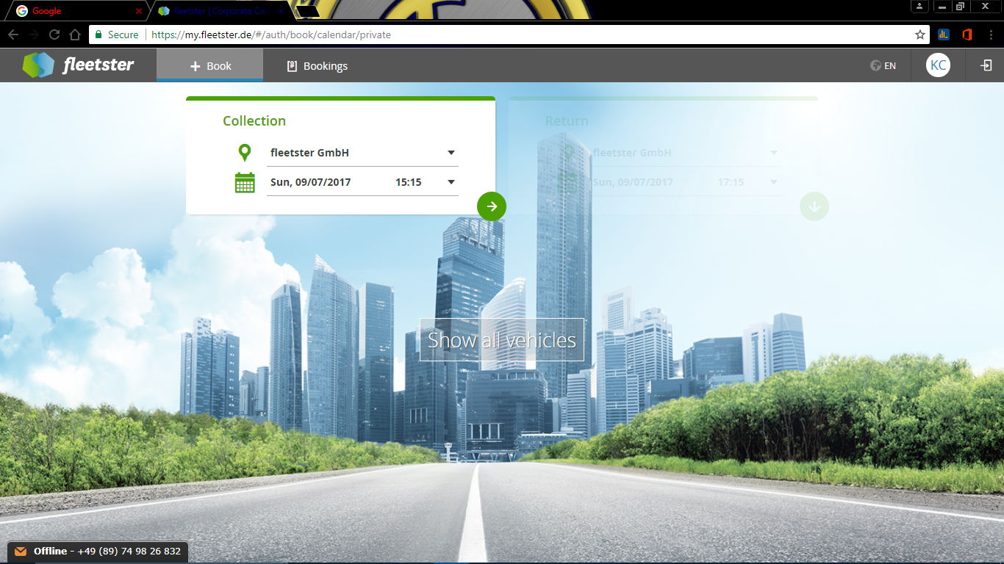

2:“Collection” panel and “Return” panel both shows same destination on change. So the Estimated Distance slider and Amount is always 0. Even on changing the Estimated Distance Manually, the Amount next to vehicle does not change.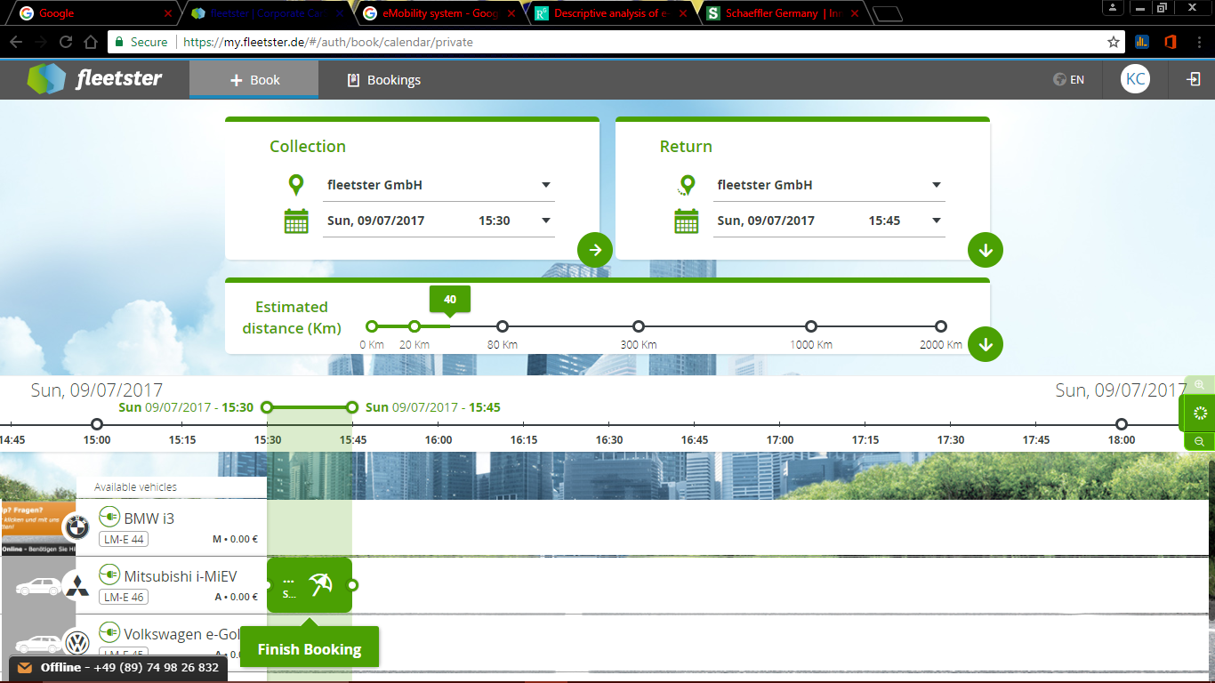

On Calculating Buffer, it always shows “charging from 0km to 120km”

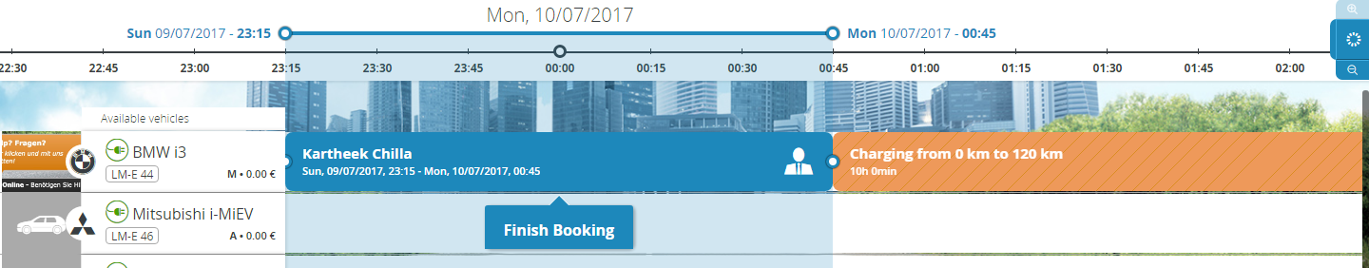

On some cars, doesn’t show anything.

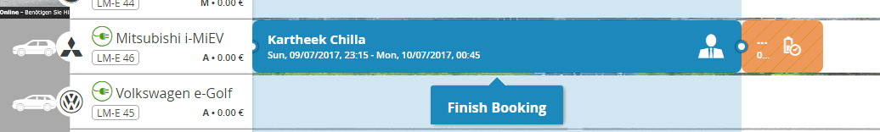

Shows a popup on finish booking

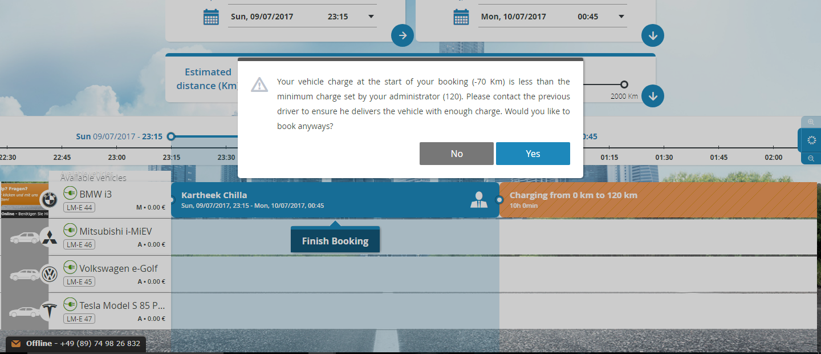

Details are different for each car

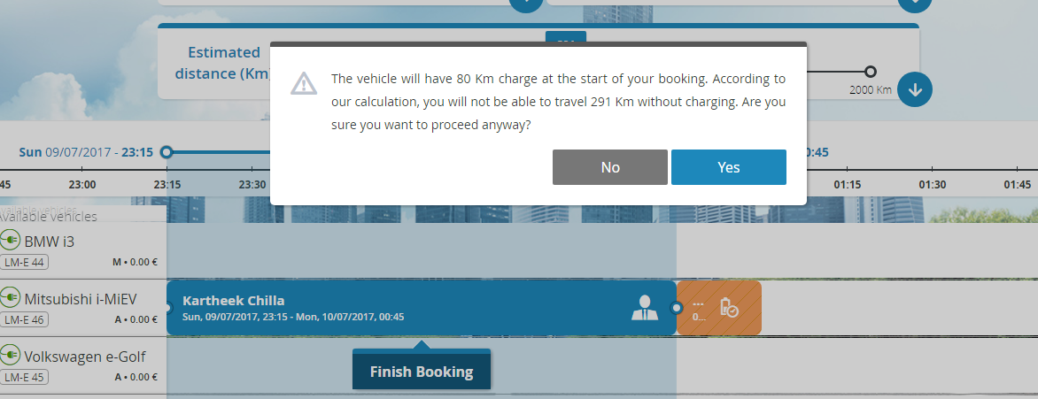

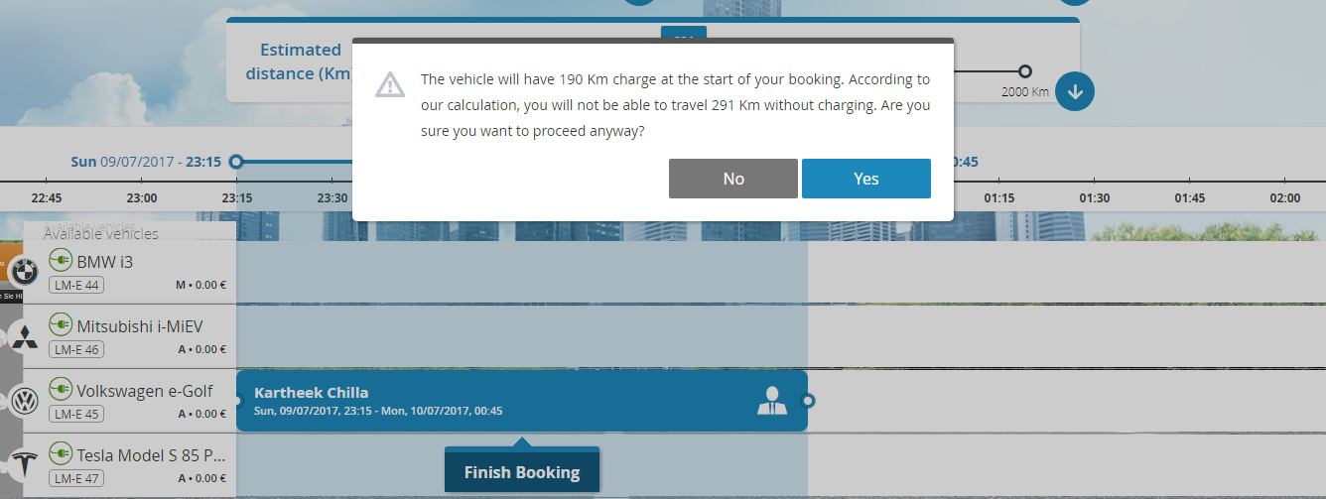

Still the Amount next to the car remains 0.

3: Repeat “NO”

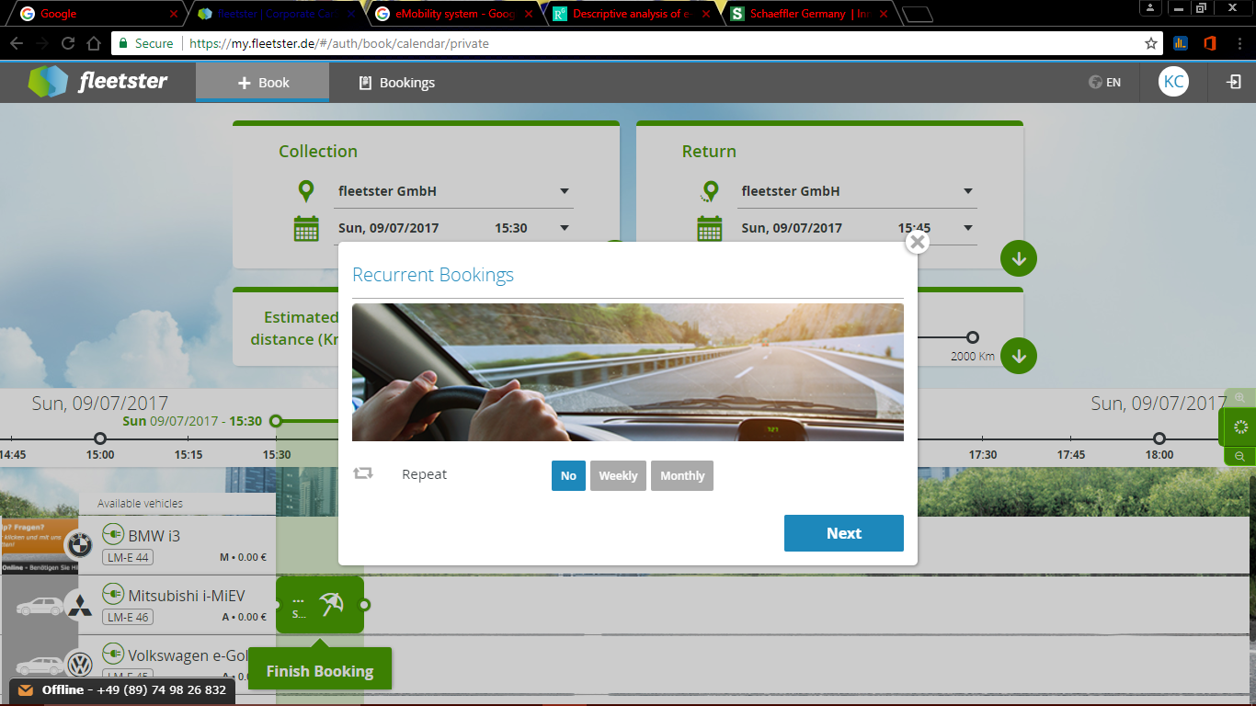

4: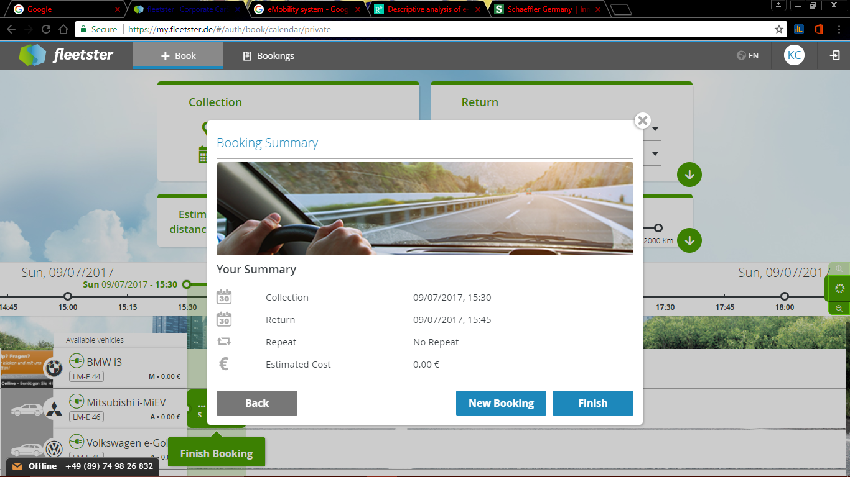

On Repeat “Yes”

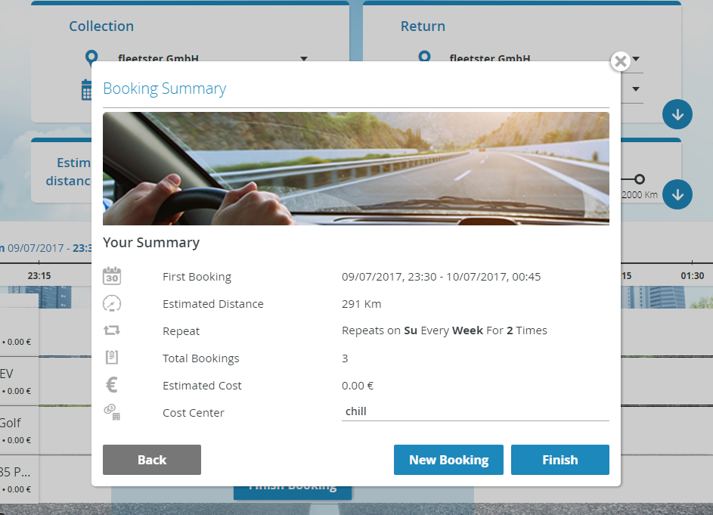

Cost is still Set to 0.

5: After pressing “Finish”

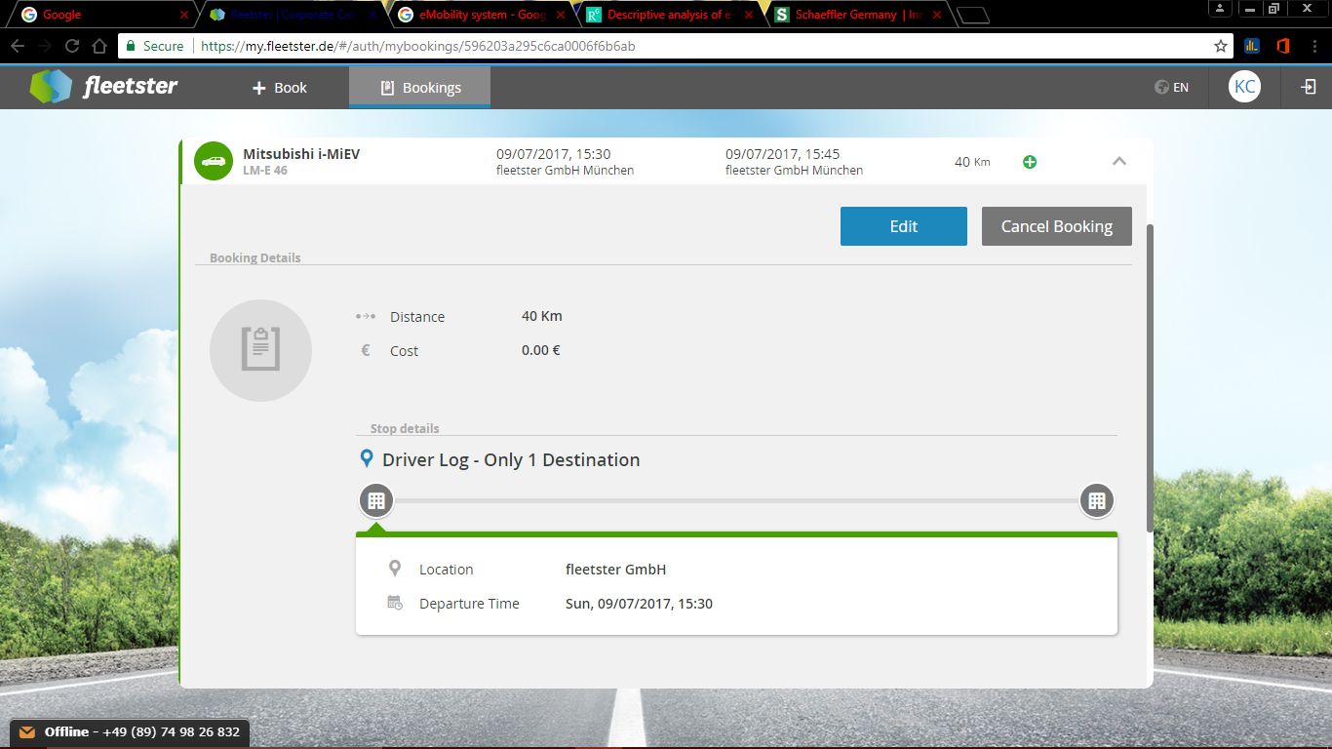

6: To change something “Edit” changing the destination.

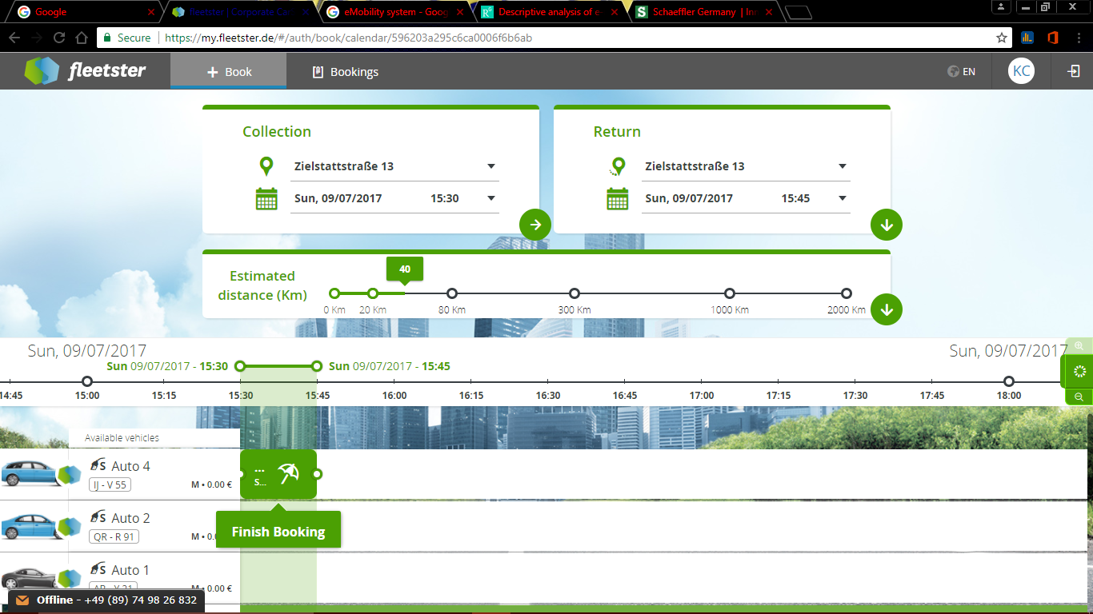

7: If we change the destination, a pop-up appears.

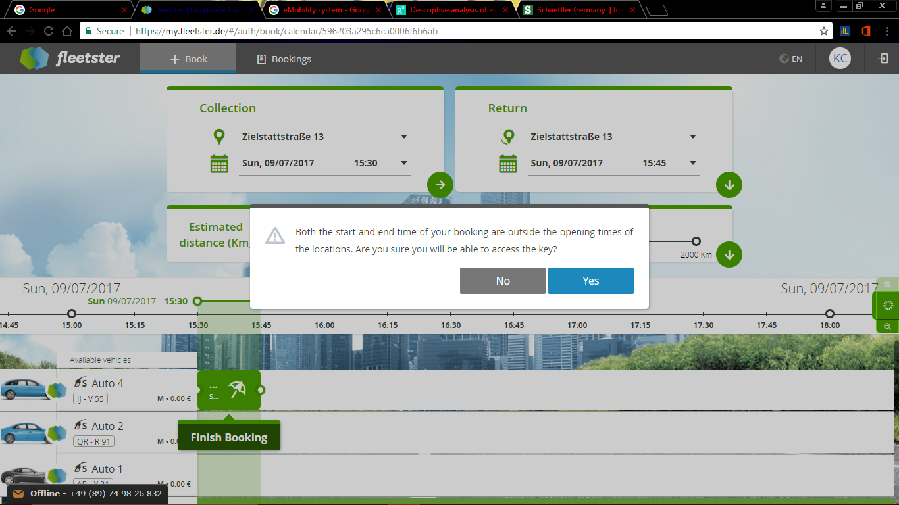

8: After Pressing “Yes” it takes us to the finish pop-up.

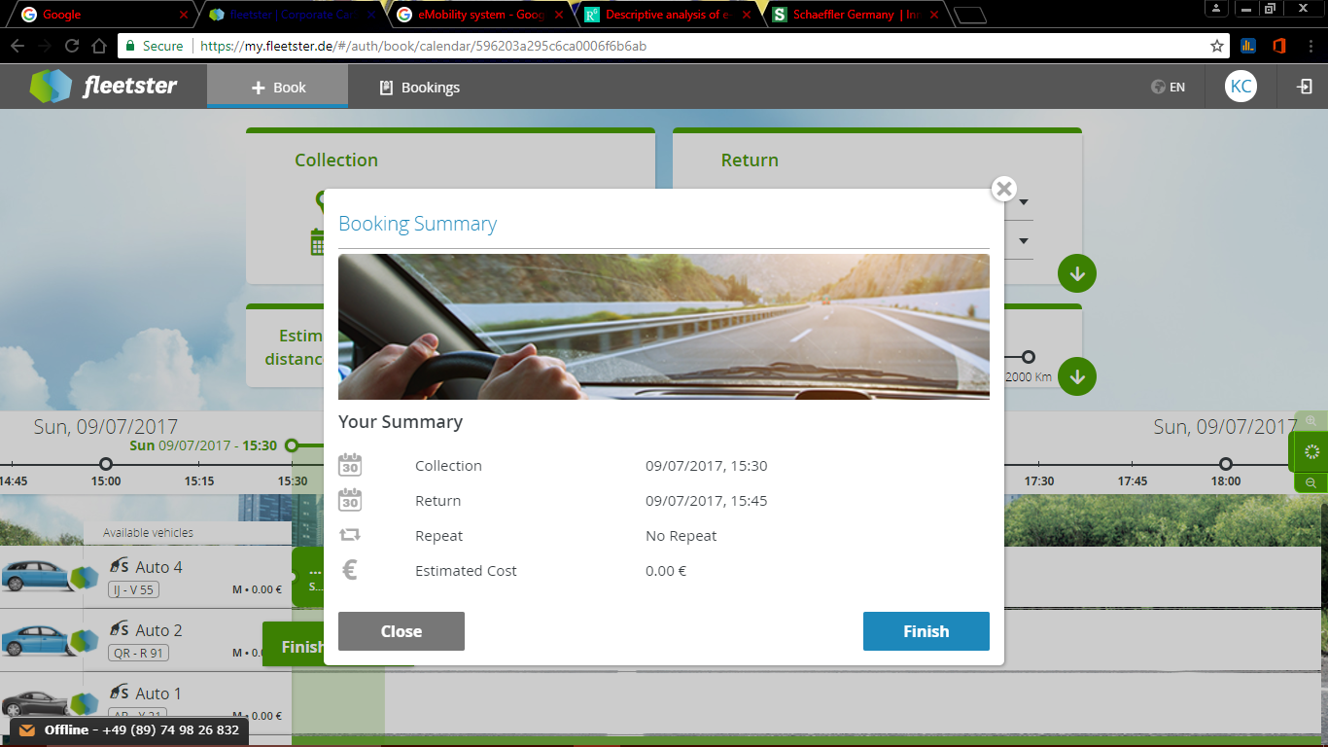

9:

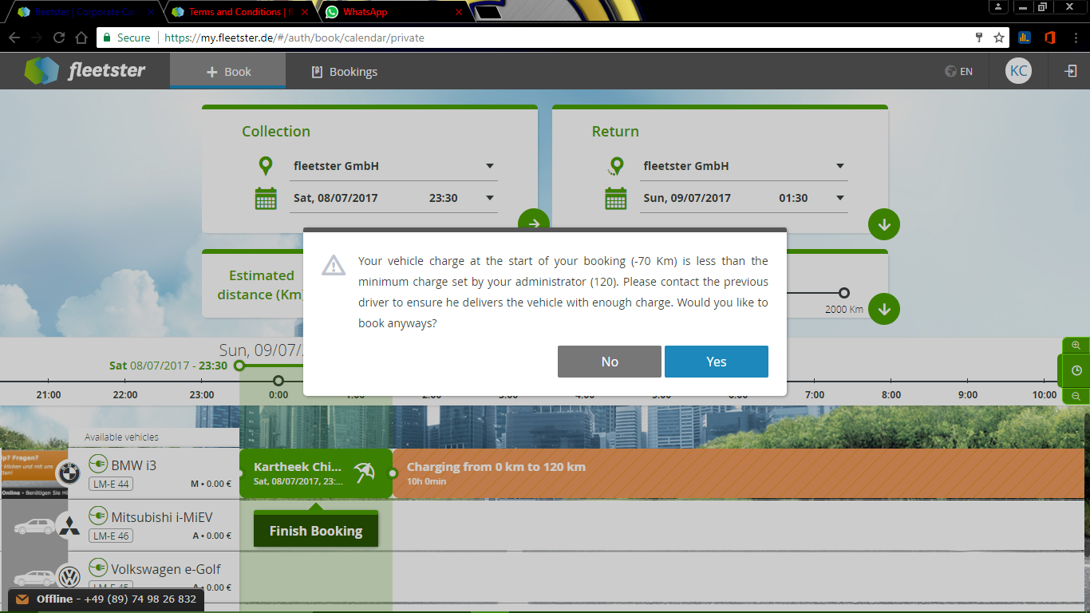

10:

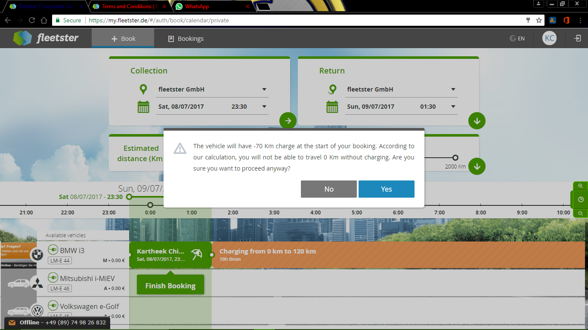

11:

